**Box Sizing**

Box Sizing property allow us to include the padding and border in an element’s total width and height.

**Without the CSS box-sizing Property**

The width and height is calculated using following:

width + padding + border = actual width of an element  
height + padding + border = actual height of an element

This means: When you set the width/height of an element, the element often appears bigger than you have set (because the element's border and padding are added to the element's specified width/height).

Ex

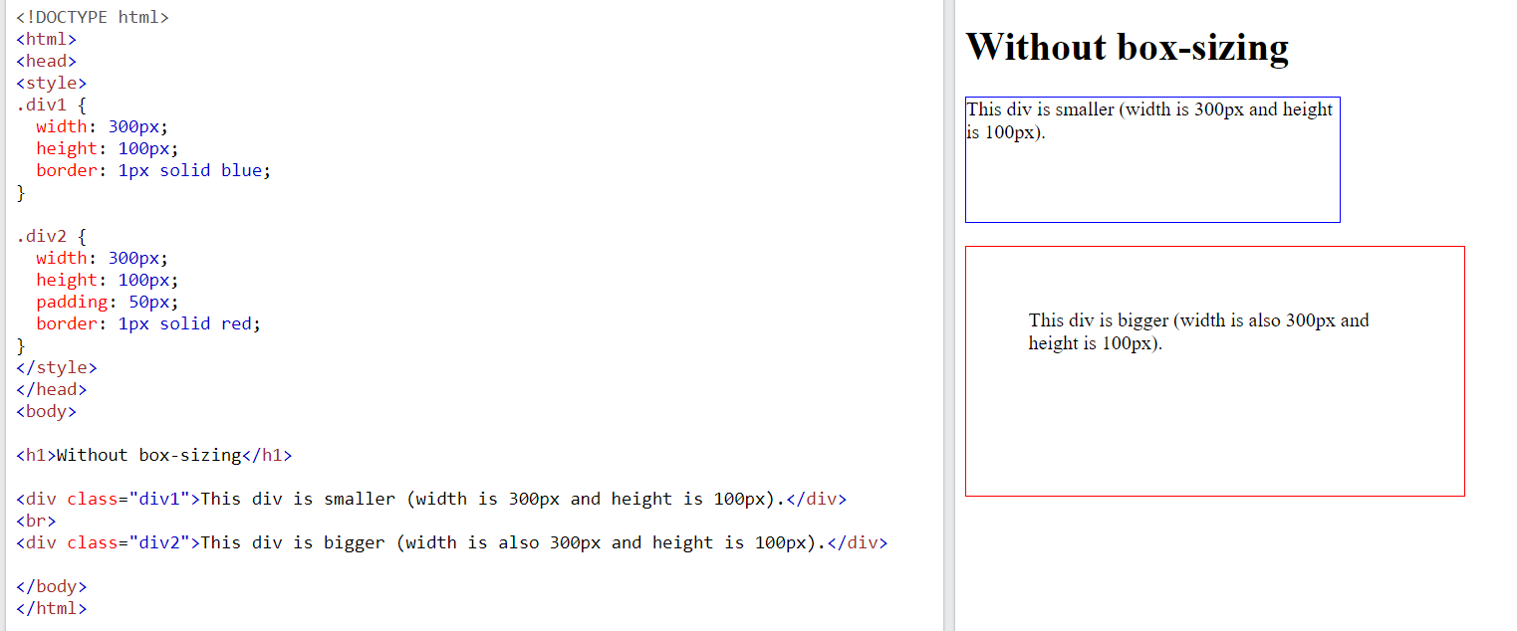

**With the CSS box-sizing Property**

* The box-sizing property allows us to include the padding and border in an element's total width and height.
* If you set box-sizing: border-box; on an element, padding and border are included in the width and height:

|  |  |
| --- | --- |
| **Property** | **Description** |
| [box-sizing](https://www.w3schools.com/cssref/css3_pr_box-sizing.asp) | Defines how the width and height of an element are calculated: should they include padding and borders, or not |

